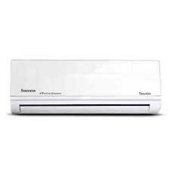

Success 1.5

* Split Heat & Cool AC
* High Quality Result
* Vary Depending Model
* Color White
* **Rs.58,500**